IOT LAB PROGRAMS (THESE WORK BUT REFER AT YOUR OWN RISK !!!!)
LAB PROGRAM - 1
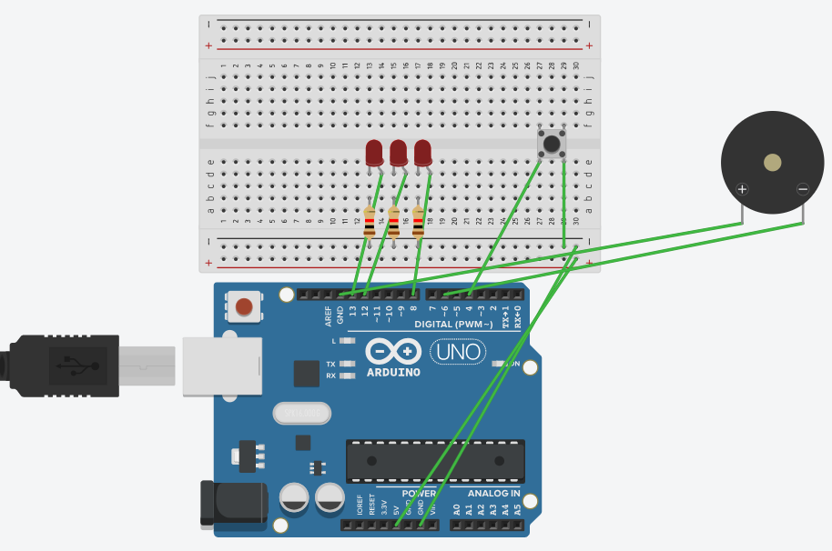
// C++ code
void setup()
{
pinMode(LED_BUILTIN, OUTPUT);
pinMode(12, OUTPUT);
pinMode(8,OUTPUT);
pinMode(6, OUTPUT);//buzzer output
pinMode(4, INPUT_PULLUP);//switch
}

void loop()
{
byte buttonState = digitalRead(4);
if (buttonState == LOW){
digitalWrite(LED_BUILTIN, HIGH);
delay(1000); // Wait for 1000 millisecond(s)
digitalWrite(LED_BUILTIN, LOW);
delay(1000); // Wait for 1000 millisecond(s)
digitalWrite(12, HIGH);
delay(1000); // Wait for 1000 millisecond(s)
digitalWrite(12, LOW);
delay(1000); // Wait for 1000 millisecond(s)
digitalWrite(8, HIGH);
delay(1000); // Wait for 1000 millisecond(s)
digitalWrite(8, LOW);
delay(1000); // Wait for 1000 millisecond(s)
tone(6,100);//buzzer sound
}
}

LAB PROGRAM - 2
IR SENSOR
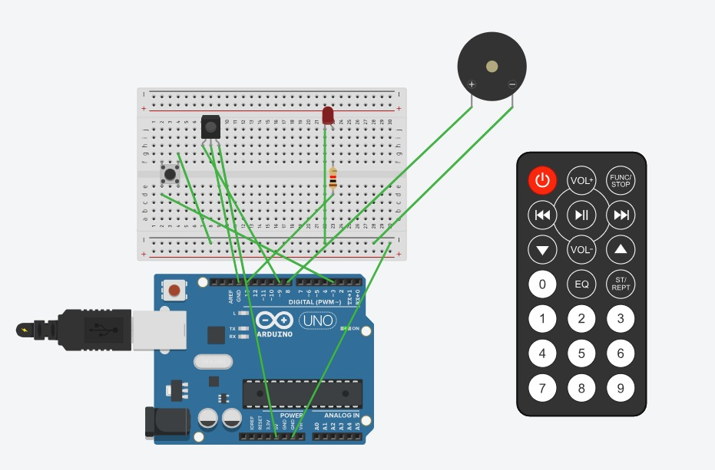
// C++ code
int IRSensor = 9;
int LED = 13;
int Buzzer = 8;
int button=3;

void setup()
{
pinMode(IRSensor, INPUT);
pinMode(LED, OUTPUT);
pinMode(Buzzer, OUTPUT);
pinMode(button,INPUT_PULLUP);
}

void loop()
{
int sensorStatus = digitalRead(IRSensor);
byte buttonstate=digitalRead(button);
if(buttonstate==HIGH){//button not pressed
if (sensorStatus == 1) //no object detected
{
digitalWrite(LED, LOW);
digitalWrite(Buzzer, LOW);
}}
else
{
digitalWrite(LED, HIGH);
digitalWrite(Buzzer, HIGH);
}
}

LAB PROGRAM - 3
Dht11 SENSOR
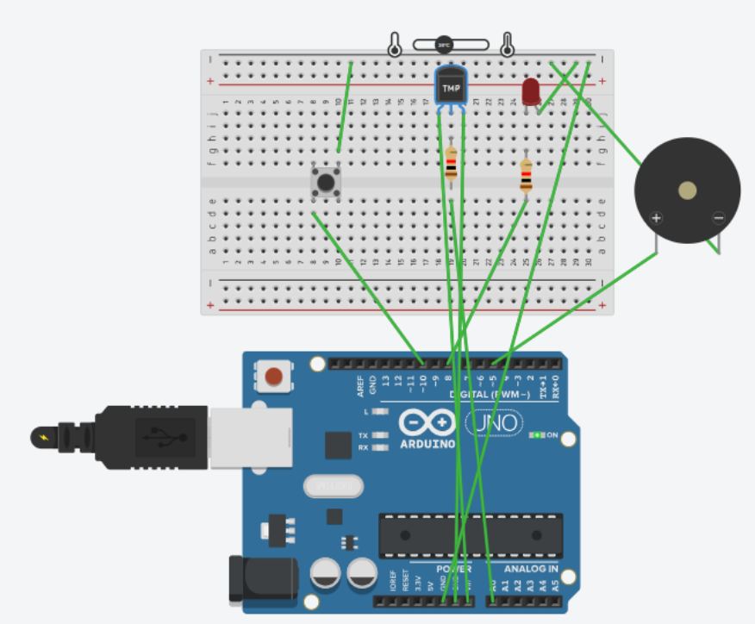
#include "DHT.h"
#define DHTPIN 7 // DHT11 data pin connected to digital pin 7
#define DHTTYPE DHT11 // DHT 11 sensor
#define LEDPIN 8 // LED connected to digital pin 8
#define BUZZERPIN 5 // Buzzer connected to digital pin 5
#define SWITCHPIN 10 // Switch connected to digital pin 10

DHT dht(DHTPIN, DHTTYPE);

void setup()
{
Serial.begin(9600);
pinMode(LEDPIN, OUTPUT);
pinMode(BUZZERPIN, OUTPUT);
pinMode(SWITCHPIN, INPUT); // Switch input
dht.begin();
}

void loop()
{
int switchState = digitalRead(SWITCHPIN); // Read the switch
if (switchState == HIGH) // If switch is ON
{
Serial.println("System ON");
float humi = dht.readHumidity();
float temp = dht.readTemperature();

Serial.print("Temperature: ");
Serial.print(temp);
Serial.println(" *C ");

Serial.print("Humidity: ");
Serial.print(humi);
Serial.println(" %");

if (temp > 25.00) {
digitalWrite(BUZZERPIN, HIGH); // Turn on buzzer
digitalWrite(LEDPIN, HIGH); // Turn on LED
delay(500);
digitalWrite(LEDPIN, LOW); // Blink LED
delay(500);
}
else {
digitalWrite(BUZZERPIN, LOW); // Turn off buzzer
digitalWrite(LEDPIN, LOW); // Ensure LED is off
delay(1000);
}
}
else // If switch is OFF
{
digitalWrite(BUZZERPIN, LOW); // Turn off buzzer
digitalWrite(LEDPIN, LOW); // Turn off LED
Serial.println("System OFF"); // Show system off
delay(1000);
}
}

LAB PROGRAM - 4
SERVO MOTOR
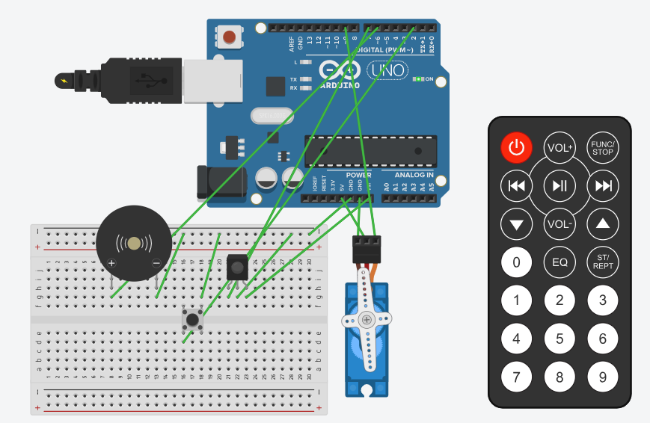

#include <Servo.h>

Servo myServo;

const int irSensorPin = 7; // Pin for the IR sensor
const int buzzerPin = 6; // Pin for the buzzer

void setup() {
myServo.attach(9); // Servo connected to pin 9
pinMode(irSensorPin, INPUT); // Set IR sensor pin as input
pinMode(buzzerPin, OUTPUT); // Set buzzer pin as output
digitalWrite(buzzerPin, LOW); // Ensure the buzzer is off initially
}

void loop() {
int sensorValue = digitalRead(irSensorPin); // Read the IR sensor's output
if (sensorValue == LOW) { // If the sensor detects an object (e.g., hand)
// Move the servo to position 0
myServo.write(0);
delay(1000); // Wait for 1 second
digitalWrite(buzzerPin, HIGH); // Turn on the buzzer
delay(500); // Keep the buzzer on for half a second
digitalWrite(buzzerPin, LOW); // Turn off the buzzer

// Move the servo to position 180
myServo.write(180);
delay(1000); // Wait for 1 second
//digitalWrite(buzzerPin, HIGH); // Turn on the buzzer again
delay(500); // Keep the buzzer on for half a second
//digitalWrite(buzzerPin, LOW); // Turn off the buzzer
} else {
// If no object is detected, turn off the servo and buzzer
myServo.write(90); // Optionally, keep the servo in the neutral position (90 degrees)
digitalWrite(buzzerPin, LOW); // Ensure the buzzer is off
}
}
Or

#include <Servo.h>

#define SERVO_PIN 4
#define BUTTON_PIN 5
#define BUZZER_PIN 9

Servo myServo;

void setup() {
pinMode(BUZZER_PIN, OUTPUT);
pinMode(BUTTON_PIN, INPUT_PULLUP);
myServo.attach(SERVO_PIN);
myServo.write(0);
digitalWrite(BUZZER_PIN, LOW);
}

void loop() {
if (digitalRead(BUTTON_PIN) == LOW) {
myServo.write(180);
digitalWrite(BUZZER_PIN, HIGH);
} else {
myServo.write(0);
digitalWrite(BUZZER_PIN, LOW);
}

delay(50);
}

LAB PROGRAM - 5
SENSOR DATA TO SMARTPHONE USING BLUETOOTH
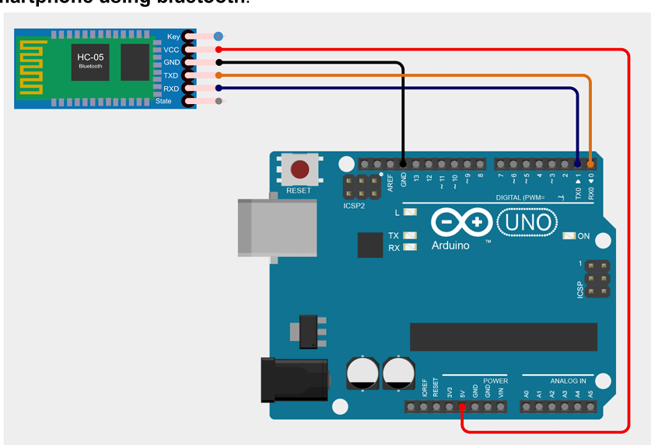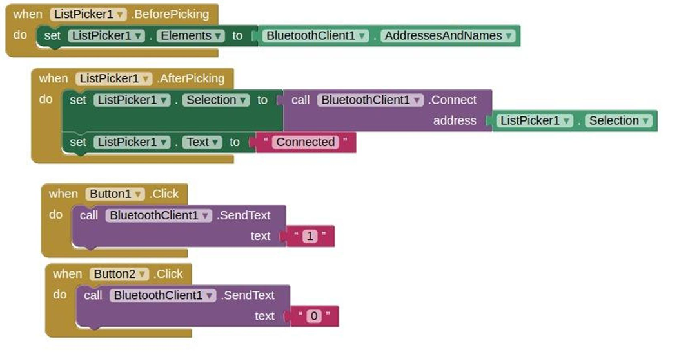

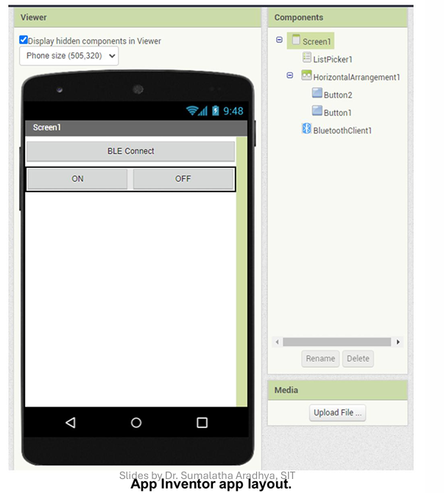

int bluetoothval=0;
int lastval;
int ledpin=13;

void setup(){
Serial.begin(9600);
pinMode(ledpin,OUTPUT);
}

void loop()
{
if(Serial.available())
{
bluetoothval=Serial.read();
}
if(bluetoothval=='1')
{
digitalWrite(ledpin,HIGH);
Serial.println("LED ON....");
lastval=bluetoothval;
}
else if(bluetoothval=='0')
{
digitalWrite(ledpin,LOW);
if(lastval=='0')
{
Serial.println("LED OFF!!");
}
}
delay(1000);
}

LAB PROGRAM - 6
GPS LOCATION TO SMARTPHONE
CIRCUIT : GPS ,BLUETOOTH,ARDUINO
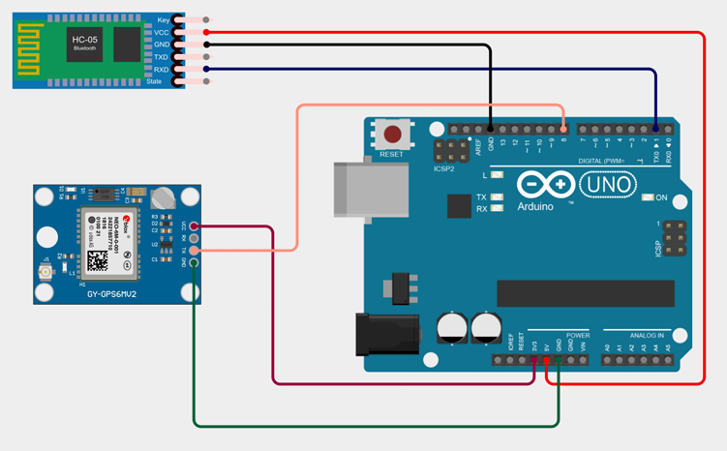
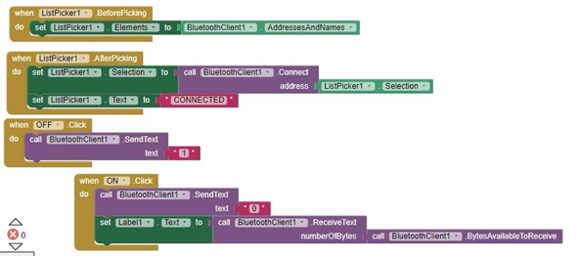
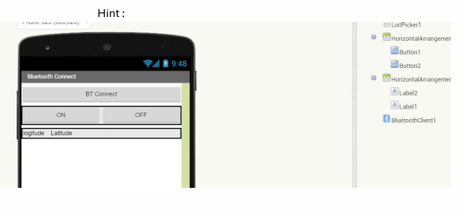

#include <TinyGPS++.h>
#include <SoftwareSerial.h>

static const int Rxpin = 8, Txpin = 8;
static const uint32_t GPSBaud = 9600;

TinyGPSPlus gps;
SoftwareSerial ss(Rxpin, Txpin);

void setup()
{
Serial.begin(9600);
ss.begin(GPSBaud);
Serial.println("Program to send GPS Coordinates Through Bluetooth");
Serial.println();
}

void loop()
{
while (ss.available() > 0)
if (gps.encode(ss.read()))
displayInfo();

if (millis() > 5000 && gps.charsProcessed() < 10)
{
Serial.print(F("No GPS detected: Check Connections "));
while (true);
}
}

void displayInfo() {
Serial.write("GPS Pointer..");
Serial.print("Location");
if (gps.location.isValid())
{
Serial.print("Latitude: ");
Serial.println(gps.location.lat(), 6);
Serial.print("Longitude: ");
Serial.println(gps.location.lng(), 6);
Serial.print("Altitude: ");
Serial.println(gps.altitude.meters());
}
else
{
Serial.println("Location: Not Available");
}
}

LAB PROGRAM - 7
VOICE COMMAND USING ARDUINO
CIRCUIT : BLUETOOTH , LED , ARDUINO
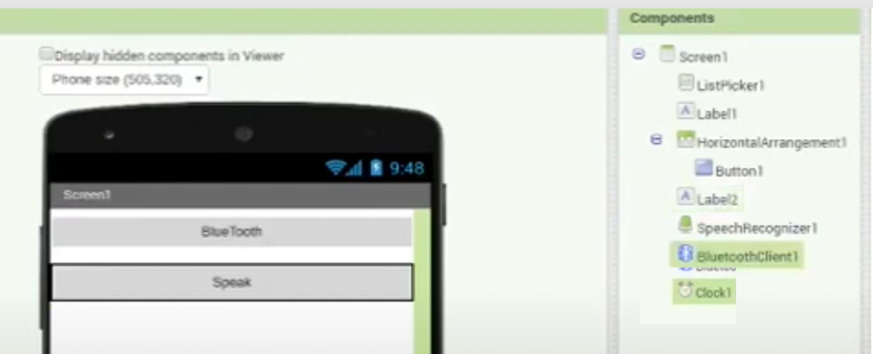
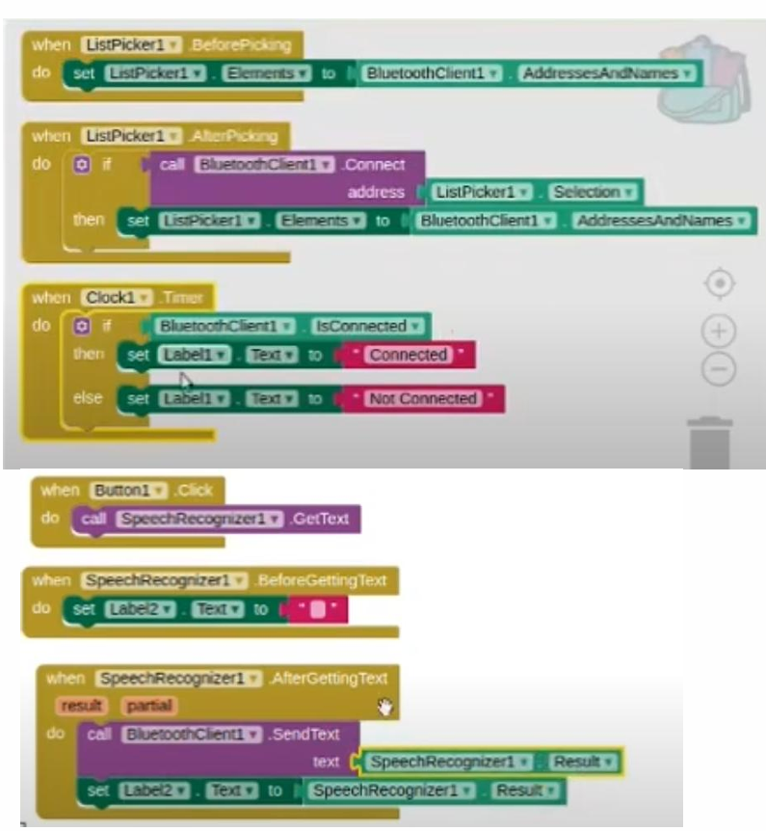s

#include <SoftwareSerial.h>

SoftwareSerial BT(0, 1);
String state = "";

void setup() {
Serial.begin(9600);
BT.begin(9600);
pinMode(2, OUTPUT);
}

void loop() {
while (BT.available()) {
delay(10);
char c = BT.read();
state += c;
}

if (state.length() > 0) {
Serial.println(state);
}

if (state == "turn on") {
digitalWrite(2, HIGH);
Serial.println("on");
}
else if (state == "turn off") {
digitalWrite(2, LOW);
Serial.println("Off");
}

state = "";
}

OR
LED with bluetooth:
char incomingChar;
void setup() {
Serial.begin(9600);
pinMode(13, OUTPUT);
}

void loop() {
if (Serial.available()) {
incomingChar = Serial.read();

if (incomingChar == '1') {
digitalWrite(13, HIGH); // Turn ON LED
}
else if (incomingChar == '0') {
digitalWrite(13, LOW); // Turn OFF LED
}
}
}
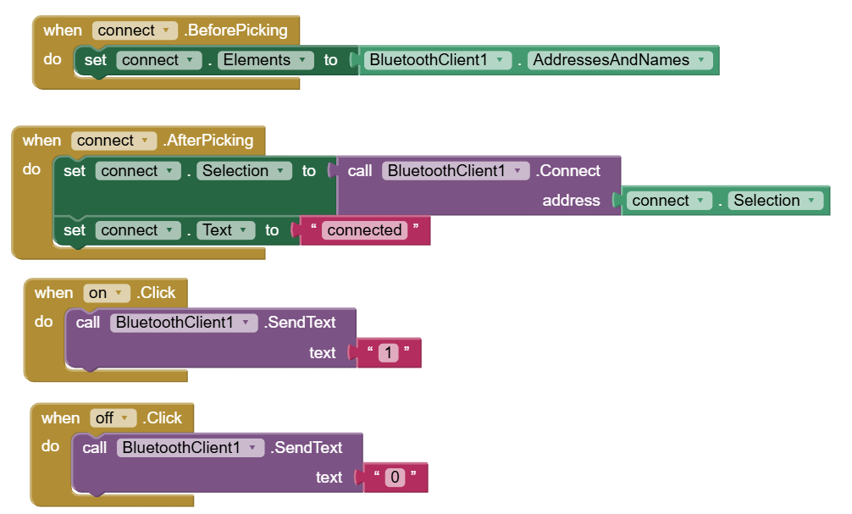

GPS with bluetooth
#include <TinyGPS++.h>
#include <SoftwareSerial.h>

TinyGPSPlus gps;
SoftwareSerial gpsSerial(8, 8); // RX and TX on pin 8

void setup() {
Serial.begin(9600);
gpsSerial.begin(9600);
}

void loop() {
while (gpsSerial.available()) gps.encode(gpsSerial.read());

if (gps.location.isValid()) {
Serial.print(gps.location.lat(), 6);
Serial.print(",");
Serial.println(gps.location.lng(), 6);
} else {
Serial.println("Not Available");
}
}
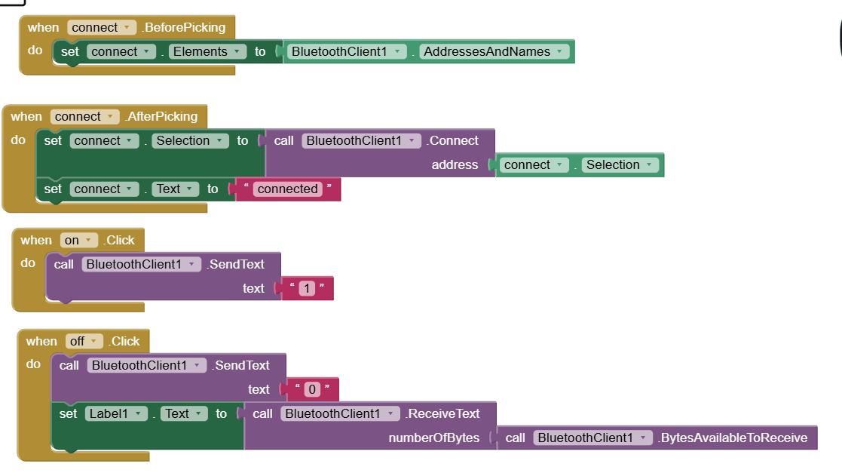

Voice with bluetooth
#include <SoftwareSerial.h>

SoftwareSerial BT(0, 1);

void setup() {
BT.begin(9600);
pinMode(13, OUTPUT);
}

void loop() {
if (BT.available()) {
String cmd = BT.readStringUntil('\n');

if (cmd == "turn on") {
digitalWrite(13, HIGH);
BT.println("LED ON");
} else if (cmd == "turn off") {
digitalWrite(13, LOW);
BT.println("LED OFF");
}
}
}
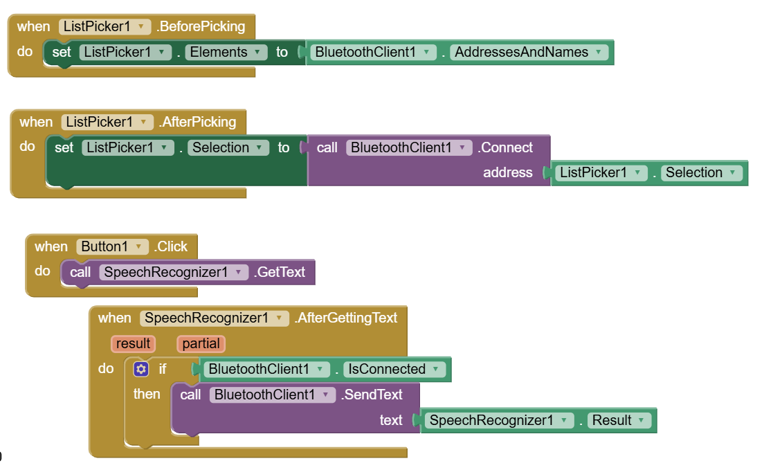

ESP
#include <WiFi.h>
#include <DHT.h>
#include <WebServer.h>
#define DHTPIN 4
#define DHTTYPE DHT11

const char* ssid = "your_wifi_name";
const char* password = "your_wifi_password";

DHT dht(DHTPIN, DHTTYPE);
WebServer server(80);

void setup() {
Serial.begin(115200);
dht.begin();
WiFi.begin(ssid, password);

while (WiFi.status() != WL_CONNECTED) {
delay(500);
Serial.print(".");
}

Serial.println("\nWiFi Connected");
Serial.println(WiFi.localIP());

server.on("/", []() {
float t = dht.readTemperature();
float h = dht.readHumidity();

String html = "<!DOCTYPE html><html><head><title>DHT11 Data</title>";
html += "<meta http-equiv='refresh' content='3'>";
html += "</head><body><h1>DHT11 Data</h1>";
html += "<p>Temp: " + String(t) + " &deg;C</p>";
html += "<p>Humidity: " + String(h) + " %</p>";
html += "</body></html>";

server.send(200, "text/html", html);
});

server.begin();
}

void loop() {
server.handleClient();
}

